

|  |
| --- |
|  |
| Translation & Review Portal 4.1  System Administrator Guide Version 1.0 |
| This documentation is proprietary and is protected by U.S. and international copyright laws and trade secret laws. Copyright © 2011 Translations.com, Inc. ("Translations.com") All rights reserved. No part of this documentation may be reproduced, copied, adapted, modified, distributed, transferred, translated, disclosed, displayed or otherwise used by anyone in any form or by any means without the express written authorization of Translations.com. Other names may be trademarks of their respective owners. |

Revision Sheet

|  |  |  |
| --- | --- | --- |
| Release No. | Date | Revision Description |
| Rev.0 | 09/30/2011 | First Release |
|  |  |  |
|  |  |  |
|  |  |  |

Contents

Revision Sheet 3

Contents 4

1 About GlobalLink Translation & Review Portal 5

2 Getting started 6

3 Submission translation workflow 12

4 Submission review workflow 13

5 Submission translation and review workflow 14

6 Basic menu options 15

7 Default color representation 17

8 Managing administrative tasks 18

9 Managing submissions 43

# About GlobalLink Translation & Review Portal

GlobalLink Translation & Review Portal (TRP) revolutionizes the way organizations manage their translation projects and internal reviews of translated content. GlobalLink Translation & Review Portal is a web-based application that provides translators with a collaborative environment to translate content with an integrated translation memory and glossary. The translated content can then be proofread and reviewed by globally distributed client reviewers who can review, revise, and comment on translations with an integrated glossary checker and filters designed to streamline the entire review process.

The System Administrator performs all the administrative tasks in the GlobalLink Translation & Review Portal. Though project management is not a regular function of this role, the System Administrator can perform all Project Manager functions.

The System Administrator section includes the following:

* Getting started
* Submission translation workflow
* Submission review workflow
* Basic menu options
* Default color representation
* Managing administrative tasks
* Managing submissions

# Getting started

This section includes basic information that will help you get started with the GlobalLink Translation & Review Portal.

* Browser support
* Screen resolution
* Logging in
* Requesting a password reminder
* GlobalLink Translation & Review Portal dashboard

## Browser support

The GlobalLink Translation & Review Portal is supported by the following browsers: IE7, IE8, Firefox 3.x, Chrome and Safari. Additionally, a 2Mb internet connection speed is recommended.

## Screen resolution

GlobalLink Translation & Review Portal supports a minimum screen resolution of 1280 x 1024.

## Logging in

To login to the GlobalLink Translation & Review Portal:

1. Using a browser, navigate to the URL provided to you.   
   The System Login page appears.  
   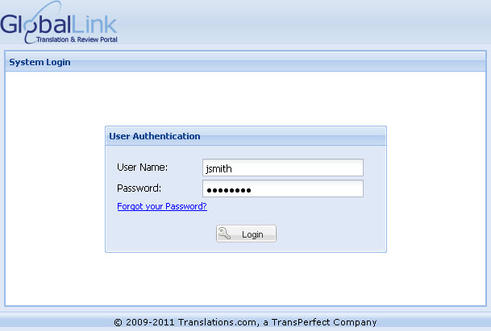
2. Enter the **User Name** and **Password**.

|  |  |  |  |
| --- | --- | --- | --- |
| Important |  |  |  |
| The System Administrator generates the user name and temporary password, which will be sent to you via email. An example screenshot of an email notification is given below. The email notification includes the Translation & Review Portal URL, submission name, user name and temporary password. When you login to GlobalLink Translation & Review Portal for the first time, you will be prompted to change the temporary password. | | | |

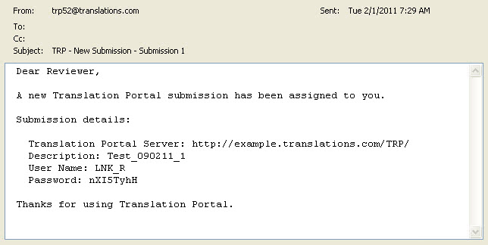

// Submission information is not included in this screenshot. Submission information like

1)Source and Target Language  
2) Creation and Due dates  
3) What stage is next

The above mentioned points are the new features implemented, when a new submission is created or assigned the Source and target languages, creation and due dates, stage and instructions(if mentioned) is displayed in the mail.

1. Click **Login**.  
   The First Login page appears.  
   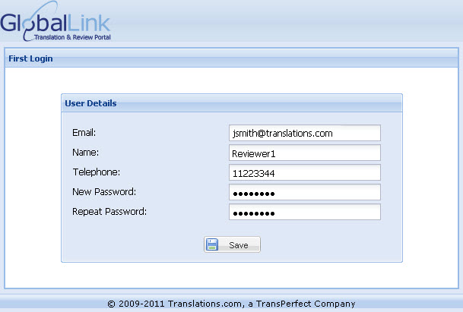
2. Enter the New Password and click **Save**.  
   GlobalLink Translation & Review Portal dashboard appears.

## Requesting a password reminder

If you have forgotten the password to login to Translation & Review Portal, you can request for a password reminder.

To get a password reminder:

1. In the System Login page, click on **Forgot your password?** link.  
   The Password Reminder Request page appears.  
   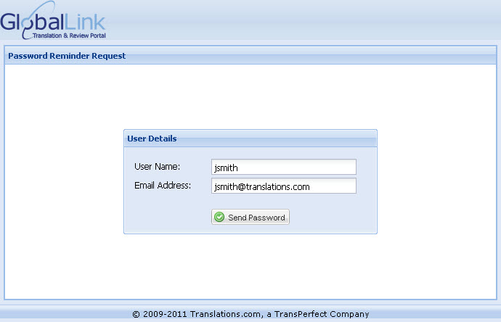
2. Enter your **User Name** and **Email Address** as set up in the Translation & Review Portal and click Send Password.  
   Your current password is sent to your email address.

## GlobalLink Translation & Review Portal dashboard

Find below the description for the various components of the GlobalLink Translation & Review Portal dashboard:

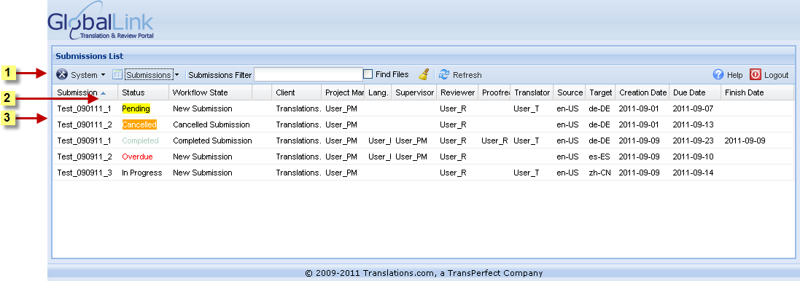

| Number | Use | to… |
| --- | --- | --- |
|  | Menu bar | carry out all System Administrator functions. You can manage administrative tasks and submissions, filter submissions, refresh dashboard, logout from the tool and view the help. Go to Basic menu options for more information. |
|  | Sorting icon | sort the submission details in ascending or descending order. |
|  | Submission list | view the details of submissions assigned to you. The submission list displays the Submission name, Status, Workflow State, Client, Project Manager, Language Manager, Supervisor, Reviewer, Proofreader, Translator, Source and Target Language, Creation Date, Due Date and Finish Date of the submissions. |

# Submission translation workflow

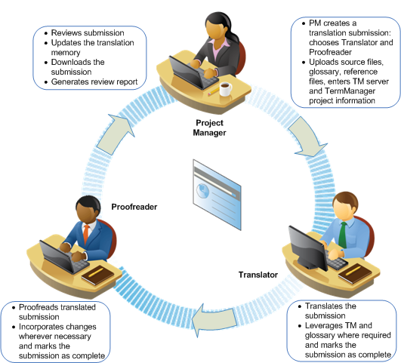

# Submission review workflow

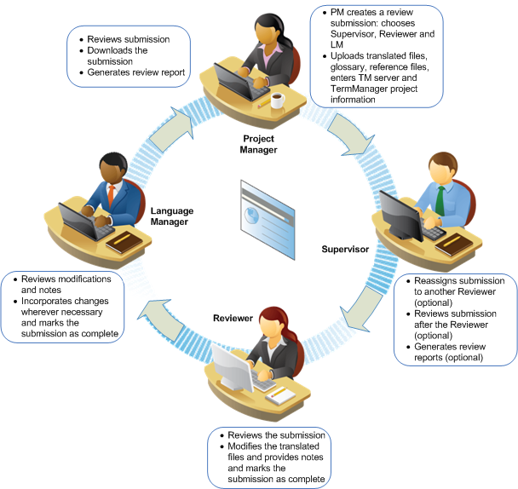

// The Supervisor in this workflow diagram is placed before Reviewer. In TRP the Supervisor workflow is placed after Review is done.

# Submission translation and review workflow

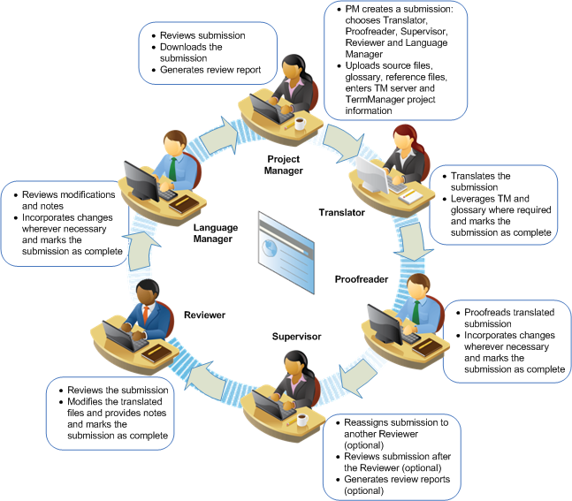

// The Supervisor in this workflow diagram is placed before Reviewer. In TRP the Supervisor workflow is placed after Review is done.

# Basic menu options

The GlobalLink Translation & Review Portal dashboard basic menu options are as follows:

| Use | to… |
| --- | --- |
| **System menu** | |
| Manage Clients | create, delete or modify clients. |
| TermManager Glossaries | add Term Manager projects which will allow reviewers to search for terms in GlobalLink Term Manager. |
| Client Glossaries | upload standard client glossaries based on source and target language pair. |
| Client TM Servers | add client-specific Translation Memory (TM) server details that will be available to the users during translation or review. |
| Submission Templates | add client-specific submission templates that can be used by project managers to quickly create submissions when majority of the entries are the same. |
| Manage Users | to create, delete and modify users, reset password and activate or inactivate user accounts. |
| LDAP Server | update LDAP server details to allow single sign on to the GlobalLink Translation & Review Portal using the user's corporate login credentials. |
| Email Server | set up or modify the email server. |
| Send Email to Active Users | send common email message to all active users. |
| Paths to Preview Files | enter the SFTP location where source files for preview will be placed. |
| Remove Temporary Files | complete server maintenance. It removes all temporary files created when you upload files for review or download a submission. |
| Download System Log | download log with submission and email activity details. |
| Clean System Log | removes old system logs. |
| About... | GlobalLink Translation & Review Portal version, build and server information. |
| **Submissions menu** | |
| Create Submission | create new translation and/or review submission by entering submission details, uploading files, glossary and reference files. |
| Open Submission | open an assigned submission for translation or review. |
| Modify Submission | modify submission details, upload or remove files and change email notification rules. |
| Submission Instructions | view special instructions to be followed when processing submissions. |
| Upload Preview Files | to view the details of the SFTP location where the preview files must be uploaded. |
| Download Submission | download the submission files to a location on your computer. |
| Export Submissions List | export the submission list to an HTML file or download as a CSV file. |
| Review Report | generate submission statistics report that includes list of files, review status, source, target and modified segments, reviewer details and notes. |
| Export Submission Files As HTML | export the submission files into HTML format. |
| Review History | view the review history of a submission. |
| Complete Submission | mark a submission as complete. |
| Reopen Submission | Reopen a completed or cancelled submission. |
| Resend Submission Notification | resend a submission notification to the user currently assigned to the submission. |
| Cancel Submission | cancel a submission. |
| Delete Submission | delete a submission. |
| Hide Completed Submissions | hide completed submissions.  Note: This option is automatically selected. To view completed submissions you must uncheck the option. |
| Hide Cancelled Submissions | hide cancelled submissions. |
| **Submissions Filter** | search for specific submissions. |
| **Refresh** | refresh the dashboard to view recently created or modified submissions. |
| **Help** | view help. |
| **Logout** | logout of GlobalLink Translation & Review Portal. |

// Create Submission From Template is not included in the above table for Submissions Menu that comes after Create Submision.

# Default color representation

The GlobalLink Translation & Review Portal incorporates different color codes to represent submission status. The color codes are as follows:

|  |  |
| --- | --- |
| Color | Representation |
| In Progress | New submissions |
| Completed | Completed submissions |
| Overdue | Delayed or submissions not completed on due date |
| Cancelled | Cancelled submissions |
| Pending | Submissions in the process of being created |
| Suspended | New submission that did not get processed |

Find below an example screenshot of colored representation of submission status.

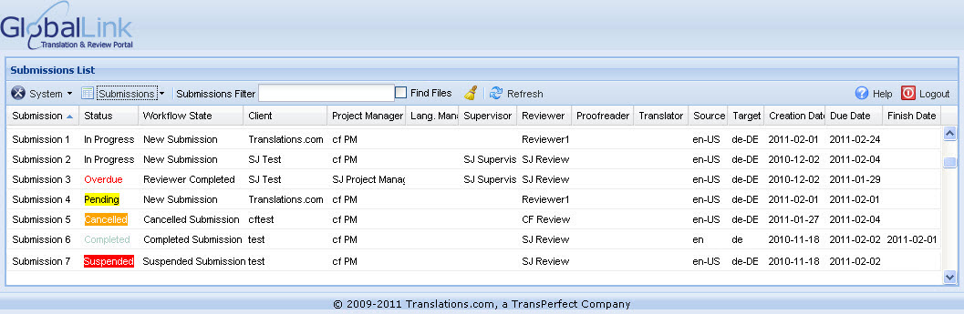

// The color code is not displayed for Cancelled in the above table.

# Managing administrative tasks

The System Administrator manages all GlobalLink Translation & Review Portal (TRP) administrative tasks. The TRP administration includes the following tasks:

* Managing clients
* Managing Term Manager glossaries
* Uploading client glossaries
* Managing client TM servers
* Managing users
* Updating LDAP server details
* Updating email server details
* Sending email to active users

## Managing clients

The System Administrator is responsible for client management. This process includes the following tasks:

* Creating a client
* Deleting a client
* Modifying a client

### Creating a client

Creating a client is the first task that a System Administrator performs. You can perform other main tasks such as creating users and submissions only after creating clients. This is because all users and submissions are associated with a particular client.

To create a client:

1. Click **Systems > Manage Clients**.  
   The Manage Clients dialog box appears.  
   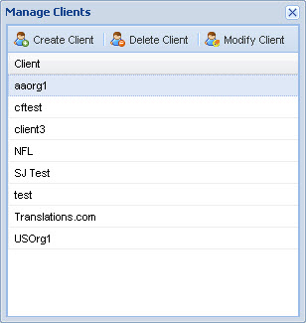
2. Click Create **Client**.  
   The Create Client dialog box appears.  
   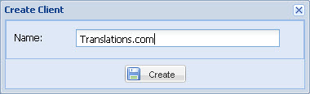
3. Enter client **Name**.

|  |  |  |  |
| --- | --- | --- | --- |
| Important |  |  |  |
| The client name must be unique to enable differentiation. If a unique name is not given, an error message appears at the bottom right hand corner of the dashboard. | | | |

1. Click **Create**.  
   A new client is created.

### Deleting a client

To delete a client:

1. Click **Systems > Manage Clients**.   
   The Manage Clients dialog box appears.
2. Click on a client name from the client list.
3. Click **Delete Client**.   
   The selected client is deleted from the client list.

|  |  |  |  |
| --- | --- | --- | --- |
| Important |  |  |  |
| The selected client cannot be deleted if there are active submissions assigned to the client. | | | |

### Modifying a client

To modify client name:

1. Click **Systems > Manage Clients**.   
   The Manage Clients dialog box appears.
2. Click on a client name from the client list.
3. Click **Modify Client**.  
   The Modify Client dialog box appears.   
   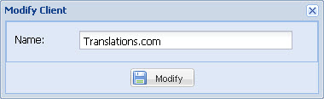
4. Modify the client name and click **Modify**.

## Managing Term Manager glossaries

The GlobalLink Translation & Review Portal Submission Review page has a Term Search option that will allow reviewers to search for terms in GlobalLink Term Manager. To enable this option you must add project details from the client's Term Manager instance. This feature includes the following tasks:

* Adding a project
* Deleting a project

### Adding a project

To add a project:

1. Click **System > TermManager Glossaries**.  
   The TermManager Glossaries dialog box appears.  
   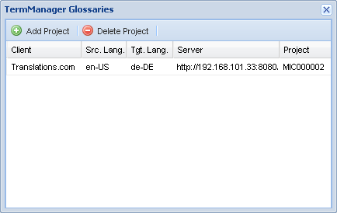
2. Click **Add Project**.  
   The Add Project dialog box appears.  
   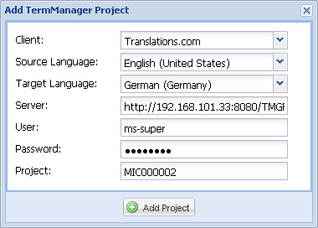
3. Complete the following entries:

| Option | Description |
| --- | --- |
| Client | Select the client name from the drop down list. |
| Source Language | Select the source language of the glossary that will be referenced. |
| Target Language | Select the target language of the glossary that will be referenced. |
| Server | Enter server information of the Term Manager instance. |
| User | Enter username of the Term Manager user. |
| Password | Enter password of the Term Manager user. |
| Project | Enter project code of the client that is set up in Term Manager. |

1. Click **Add Project**.  
   The project details appear in the TermManager Glossaries dialog box.

### Deleting a project

To delete a project:

1. Click **System > TermManager Glossaries**.   
   The TermManager Glossaries dialog box appears.
2. Click on a project from the project list.
3. Click **Delete Project**.   
   The selected project is deleted from the project list.

|  |  |  |  |
| --- | --- | --- | --- |
| Important |  |  |  |
| You cannot retrieve a deleted project, it must be added again. | | | |

## Uploading client glossaries

The administrator can upload client-specific glossaries that will always be available to the users during translation or review. The project manager can upload additional glossaries if required during submission creation.

To upload client glossaries:

1. Click **Systems > Client Glossaries**.   
   The Client Glossaries dialog box appears.  
   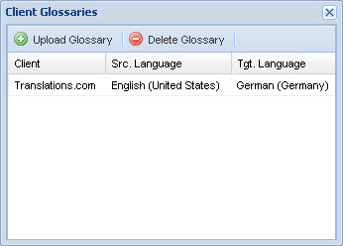
2. Click **Upload Glossary**.  
   The Upload Glossary dialog box appears.  
   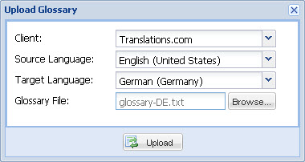
3. Complete the following entries:

| Option | Description |
| --- | --- |
| Client | Select the client name. |
| Source Language | Select the source language of the glossary. |
| Target Language | Select the target language of the glossary. |
| Glossary File | Browse and select the glossary file.  **Note**: The glossary file should be in tab-delimited format and UTF-8 or UTF-16 encoded without a unicode signature (BOM). |

1. Click **Upload**.  
   The email server details are updated.

## Managing client Translation Memory (TM) servers

The administrator can upload client-specific Translation Memory (TM) server details that will be available to the users during translation or review. The project manager can change this TM server details by adding new information during submission creation. This feature includes the following tasks:

* Adding TM Server
* Modifying TM Server
* Deleting TM Server

### Adding TM server

To add a TM Server:

1. Click **System > Client TM Servers**.  
   The TM Server dialog box appears.  
   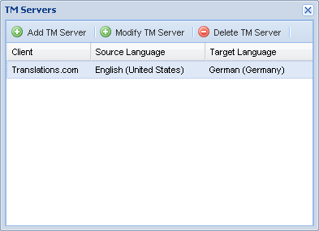
2. Click **Add TM Server**.  
   The Add New TM Server dialog box appears.  
   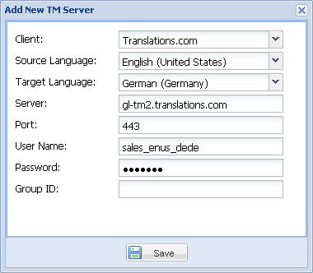
3. Complete the following entries:

| Option | Description |
| --- | --- |
| Client | Select the client name from the drop down list. |
| Source Language | Select the source language of the translation memory. |
| Target Language | Select the target language of the translation memory. |
| Server | Enter the server address for the translation memory. |
| Port | Enter the translation memory port number. |
| User name | Enter the user name to connect to the translation memory. |
| Password | Enter the password to connect to the translation memory. |
| Group ID | Enter the group ID.  **Note**: The group ID is a 10 digit number and is provided to you by the client. |

1. Click **Save**.  
   The TM Server details appear in the TM Servers dialog box.

### Modifying TM server

To modify a TM Server:

1. Click **System > Client TM Servers**.   
   The TM Servers dialog box appears.
2. Click on a client name from the TM server list.
3. Click **Modify TM Server**.  
   The Modify TM Server dialog box appears.
4. Modify the TM Server details and click **Save**.

### Deleting TM server

To delete a TM Server:

1. Click **System > Client TM Servers**.   
   The TM Servers dialog box appears.
2. Click on a client name from the TM server list.
3. Click **Delete TM Server**.   
   The selected TM server is deleted from the TM server list.

|  |  |  |  |
| --- | --- | --- | --- |
| Important |  |  |  |
| You cannot retrieve a deleted TM server, it must be added again. | | | |

## Managing submission templates

The administrator can upload client-specific submission templates that can be used by project managers to quickly create submissions when majority of the entries are the same. This feature includes the following tasks:

* Adding Template
* Modifying Template
* Deleting Template

### Adding template

To add a submission template:

1. Click **System > Submission Templates**.  
   The Manage Submission Templates dialog box appears.  
   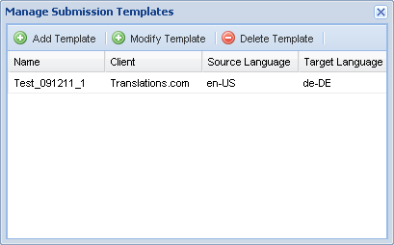
2. Click **Add Template**.  
   The New Template dialog box appears.  
   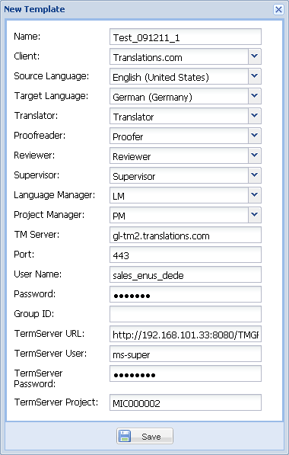
3. Complete the following entries:

| Option | Description |
| --- | --- |
| Name | Enter a unique template name. |
| Client | Select a client name or type the first few characters to automatically fill the field. |
| Source Language | Select the source language for the submission or type the first few characters to automatically fill the field. |
| Target Language | Select the target language for the submission or type the first few characters to automatically fill the field. |
| Translator | Select a translator for the translation submission or type the first few characters to automatically fill the field.  **Note**: The client selection will influence the Translator chosen for the submission. You can only choose from those users who are assigned to the particular client. |
| Proofreader | Select a proofreader for the translation submission or type the first few characters to automatically fill the field.  **Note**: The client selection will influence the Proofreader chosen for the submission. You can only choose from those users who are assigned to the particular client. |
| Reviewer | Select a reviewer for the review submission or type the first few characters to automatically fill the field.  **Note**: The client selection will influence the Reviewer chosen for the submission. You can only choose from those users who are assigned to the particular client. |
| Supervisor | Select a supervisor for the review submission or type the first few characters to automatically fill the field.  **Note**: The client selection will influence the Supervisor chosen for the submission. You can only choose from those users who are assigned to the particular client. |
| Language Manager | Select a language manager for the review submission or type the first few characters to automatically fill the field. |
| Project Manager | Select a project manager for the submission or type the first few characters to automatically fill the field. |
| TM Server | Enter the server address for the translation memory.  **Note**: The TM Server information that is pre populated from the template can be changed during submission creation. The information entered at the submission creation level will take precedence over that entered by the administrator in the Client TM Servers option. |
| Port | Enter the translation memory port number. |
| User Name | Enter the user name to connect to the translation memory. |
| Password | Enter the password to connect to the translation memory. |
| Group ID | Enter the group ID.  **Note**: The group ID is a 10 digit number and is provided to you by the client. |
| TermServer URL | Enter server information of the Term Manager instance. |
| TermServer User | Enter username of the Term Manager user. |
| TermServer Password | Enter password of the Term Manager user. |
| TermServer Project | Enter project code of the client that is set up in Term Manager. |

1. Click **Save**.  
   The new template appears in the Manage Submission Templates dialog box.

### Modifying template

To modify a submission template:

1. Click **System > Submission Templates**.   
   The Manage Submission Templates dialog box appears.
2. Click on a submission template from the list.
3. Click **Modify Template**.  
   The Modify Template dialog box appears.
4. Modify the template details and click **Save**.

### Deleting template

To delete a submission template:

1. Click **System > Submission Templates**.   
   The Manage Submission Templates dialog box appears.
2. Click on a submission template from the list.
3. Click **Delete Template**.   
   The selected submission template is deleted from the list.

|  |  |  |  |
| --- | --- | --- | --- |
| Important |  |  |  |
| You cannot retrieve a deleted submission template, it must be added again. | | | |

## Managing Users

The System Administrator is responsible for user management. This process includes the following tasks:

* User roles
* Creating a user
* Deleting a user
* Modifying a user
* Resetting the password
* Setting active/inactive status

### User roles

The different user roles that can be configured in the Translation & Review Portal (TRP) are as follows:

* System Administrator: The System Administrator performs all the administrative tasks in the TRP. Though project management is not a regular function of this role, the System Administrator can perform all Project Manager functions.
* Account Manager: The Account Manager can keep track of the progress of submissions using the TRP. They can modify and download submissions and generate review reports.
* Project Manager: The Project Manager creates and manages all submissions for a particular client. After the submission files are translated or reviewed, the Project Manager completes a final check of the files, before being finalized. The Project Manager can also download submissions and generate review reports.
* Linguist (Translator, Proofreader, Reviewer and Language Manager): The Translator, Reviewer and Proofreader could be a vendor or organization user who translates source content and reviews and proofreads target content. They could also use an integrated translation memory and glossary.  
  The Language Manager is a language expert. After the submission files are reviewed by the Reviewer (or Supervisor), the Language Manager completes a thorough check of the changes and also implements changes that the Reviewer requests through the Comments field in the tool. The Language Manager then submits the files to the Project Manager, who conducts the final review, completing the submission review cycle.
* Supervisor: The Supervisor is responsible for monitoring submissions. After the submission files are reviewed by the Reviewer, the Supervisor completes a thorough check of the changes and submits the files to the Language Manager (if the workflow includes the Language Manager review step) or Project Manager. The Supervisor can also reassign submissions to other Reviewers and generate review reports.

### Creating a user

|  |  |  |  |
| --- | --- | --- | --- |
| Important |  |  |  |
| If the user requires LDAP authentication, ensure that the user is created on the LDAP server and Translation & Review Portal. | | | |

To create a user:

1. Click **Systems > Manage Users**.   
   The Manage Users dialog box appears.
2. Click **Create User**.   
   The Create User dialog box appears.  
   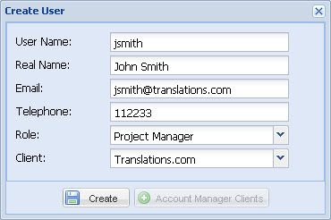
3. Complete the following entries:

| Option | Description |
| --- | --- |
| User Name | Enter new user's User Name. This will be used to login. |
| Real Name | Enter the new user's actual name. |
| Email | Enter new user's e-mail address. |
| Telephone | Enter new user's telephone number. |
| Role | Select the role of the new user. Go to User roles on page 32 for more information. |
| Client | Select the client that the new user is assigned to. |

1. If you choose the role as Account Manager, then the **Account Manager Clients** button is activated as shown in the screenshot below.  
   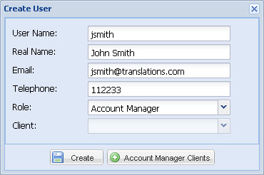

|  |  |  |  |
| --- | --- | --- | --- |
| Important |  |  |  |
| This option enables account managers to manage multiple clients at the same time. | | | |

1. Click **Account Manager Clients**.  
   The Select Clients dialog box appears.   
   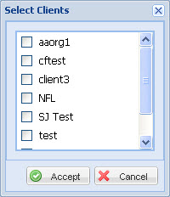
2. Select the clients managed by the account manager and click **Accept**.
3. Click **Create**.
4. The new user is created and the user details appear in the Manage Users dialog box.

|  |  |  |  |
| --- | --- | --- | --- |
| Important |  |  |  |
| The temporary password for the new user is automatically generated by the system, and is sent to the user via email. The user will be prompted to change the temporary password upon first login. | | | |

// The following sentences can be added to the above Important message: The temporary password is sent for Account manager and Project Manager when an account is created for them. For Linguist users the temporary password is sent when an submission is created and assigned to them.

### Deleting a user

To delete a user:

1. Click **Systems > Manage Users**.   
   The Manage Users dialog box appears.  
   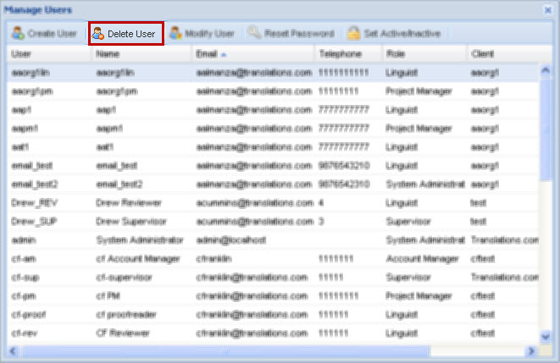
2. Click on a user from the user list.
3. Click **Delete User**.   
   The selected user is deleted from the user list.

|  |  |  |  |
| --- | --- | --- | --- |
| Important |  |  |  |
| The selected user cannot be deleted if they are participated in any submission. If the user is an Account Manager assigned to a client, then the user must be removed from the list of Account Managers. However, a user can be inactivated even if currently assigned to a submission. Once inactivated the user cannot login to the tool. | | | |

### Modifying a user

To modify a user:

1. Click **Systems > Manage Users**.   
   The Manage Users dialog box appears.
2. To select a user from the user list, click on the user.
3. Click **Modify User**.   
   The Modify User dialog box appears.  
   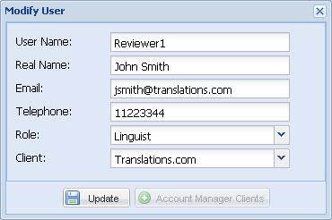
4. Complete the following entries:

| Option | Description |
| --- | --- |
| User Name | This option is disabled. |
| Real Name | Modify user's actual name. |
| Email | Modify user's e-mail address. |
| Telephone | Modify user's telephone number. |
| Role | Modify the role of the user. Go to User roles for more information. |
| Client | Modify the client that the new user is assigned to. |

1. Click **Update**.  
   The user details are modified and appear in the Manage Users dialog box.

### Resetting the password

To reset user password:

1. Click **Systems > Manage Users**.   
   The Manage Users dialog box appears.  
   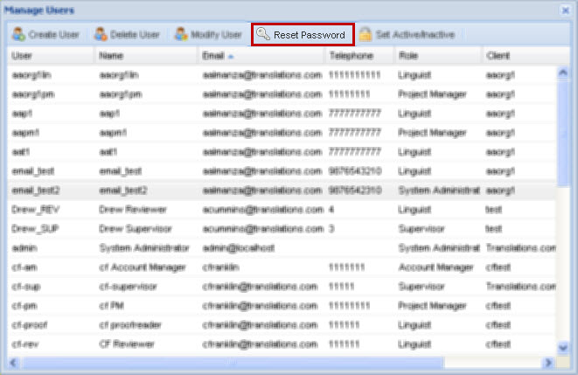
2. To select a user from the user list, click on the user.
3. Click **Reset Password**.   
   The current password of the selected user is reset and the system sends an automated email notification.

|  |  |  |  |
| --- | --- | --- | --- |
| Important |  |  |  |
| The email notification includes the GlobalLink server path, user name and new password details. The new password is valid only for a single login as the user is required to change the password. | | | |

### Setting Active/Inactive status

To set a user as active or inactive:

1. Click **Systems > Manage Users**.   
   The Manage Users dialog box appears.
2. To select a user from the user list, click on the user detail.
3. Click **Set Active/Inactive**.   
   The selected user is marked as active or inactive.

|  |  |  |  |
| --- | --- | --- | --- |
| Important |  |  |  |
| The active/inactive status is represented using color codes. In the Manage Users dialog box, the user name is highlighted in red (inactive) and white (active) as shown in the screenshot below. A user can be inactivated even if currently assigned to a submission. Once inactivated the user cannot login to the tool. | | | |

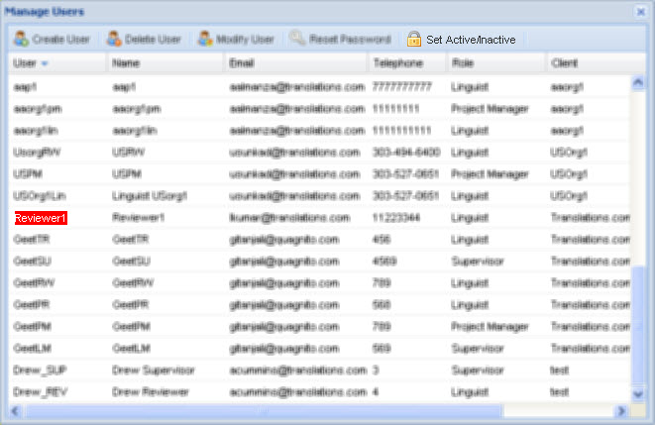

## Updating LDAP server details

The LDAP server authentication option allows single sign on to the GlobalLink Translation & Review Portal using the user’s corporate login credentials.

To update LDAP server details:

1. Click **Systems > LDAP Server**.   
   The LDAP Server dialog box appears.  
   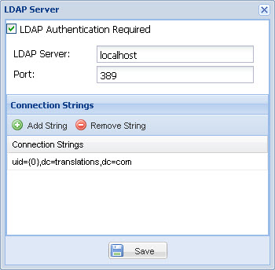
2. Complete the following entries:

| Option | Description |
| --- | --- |
| LDAP Authentication Required | Select checkbox if LDAP authentication is required. |
| LDAP Server | Enter the LDAP server name or IP address. |
| Port | Enter port number. |
| Add String | Click to enter a new connection string. |
| Remove String | Select an existing string and click to remove. |

1. Click **Save**.  
   The LDAP server details are updated.

## Updating email server details

To update email server details:

1. Click **Systems > Email Server**.   
   The Email Server dialog box appears.  
   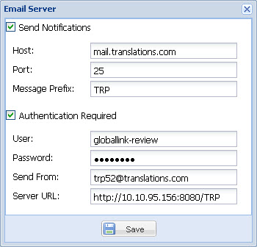
2. Complete the following entries:

| Option | Description |
| --- | --- |
| Send Notifications | Select checkbox to send notifications to users. |
| Host | Enter the host name. |
| Port | Enter port number. |
| Message Prefix | Enter the text that appears in the subject of the email. |
| Authentication Required | Select if an authentication is required. |
| User | Enter user account to authenticate on the SMTP server. |
| Password | Enter password. |
| Send From | Enter email address from where automated email notifications will be sent. |
| Server URL | Enter Server URL. |

1. Click **Save**.  
   The email server details are updated.

## Sending email to active users

To send email to active users:

1. Click **Systems > Send Email to Active Users**.   
   The Send Email to Active Users dialog box appears.  
   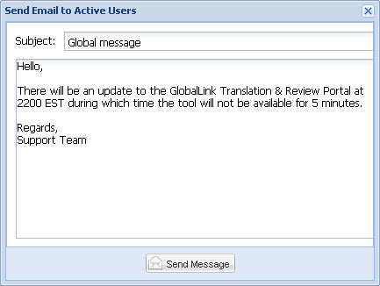
2. Enter the Subject line and email text and click Send Message.  
   The message is sent to all active users of the instance.

# Managing submissions

In addition to administration, the System Administrator has all project manager rights. As a System Administrator, you can manage submissions and generate review reports. The project management process includes the following tasks:

* Creating a submission
* Creating a submission from template
* Modifying a submission
* Deleting a submission
* Downloading a submission
* Generating a review report
* Viewing or hiding completed submissions
* Viewing review history
* Reopening a submission

## Creating a submission

To create a submission:

1. On the System Administrator dashboard, click **Submissions > Create Submission** as shown in the screenshot below.  
   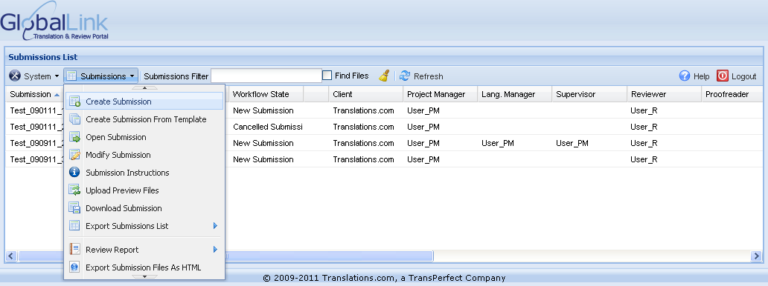  
   The Create Submission wizard - Submission Details dialog box appears.  
   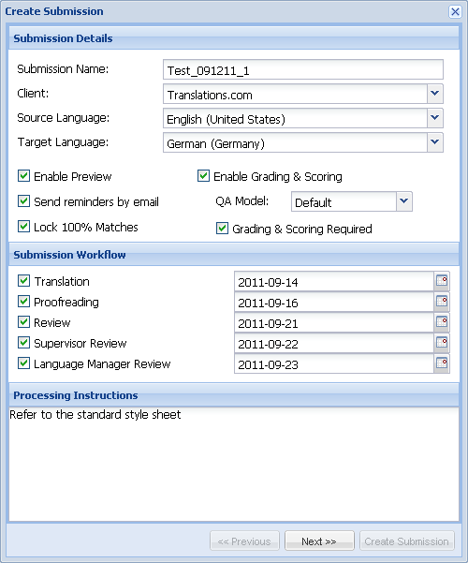
2. Complete the following entries:

| Option | Description |
| --- | --- |
| **Submission Details** | |
| Submission Name | Enter a unique submission name. |
| Client | Select a client name or type the first few characters to automatically fill the field. |
| Source Language | Select the source language for the submission or type the first few characters to automatically fill the field. |
| Target Language | Select the target language for the submission or type the first few characters to automatically fill the field. |
| Enable Preview | Select to enable preview of source files. |
| Sending reminders by email | Select checkbox to send regular reminders for open submissions. This is configured at the server level, not by default. This setting is global for all clients. |
| Lock 100% Matches | lock 100% matched target segments, to ensure users do not modify them. |
| Enable Grading & Scoring | Select to enable grading and scoring of translated content. You can choose from three Quality Assurance models:   * Localization Industry Standards Association * SAE J2450 * Default |
| QA Model | Select your preferred QA Model or type the first few characters to automatically fill the field. |
| Grading & Scoring Required | Select if grading and scoring of translated content is mandatory |
| **Submission Workflow** | Select the submission workflow. You can choose either Translation or Review or both. If required you can add Proofreading, Supervisor and Language Manager review steps to the workflows.  Select or type the due date for submission completion.  The date format is yyyy-mm-dd. |
| **Processing Instructions** | Type in any instructions for the translators or reviewers involved in the submission. |

1. Click **Next**.  
   The Create Submission wizard - Submission Participants dialog box appears.  
   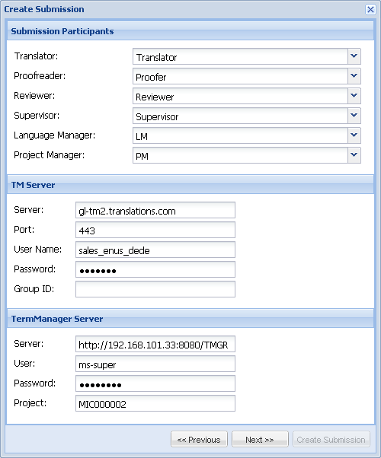
2. Complete the following entries:

| Option | Description |
| --- | --- |
| Translator | Select a translator for the translation submission or type the first few characters to automatically fill the field.  **Note**: The client selection will influence the Translator chosen for the submission. You can only choose from those users who are assigned to the particular client. |
| Proofreader | Select a proofreader for the translation submission or type the first few characters to automatically fill the field.  **Note**: The client selection will influence the Proofreader chosen for the submission. You can only choose from those users who are assigned to the particular client. |
| Reviewer | Select a reviewer for the review submission or type the first few characters to automatically fill the field.  **Note**: The client selection will influence the Reviewer chosen for the submission. You can only choose from those users who are assigned to the particular client. |
| Supervisor | Select a supervisor for the review submission or type the first few characters to automatically fill the field.  **Note**: The client selection will influence the Supervisor chosen for the submission. You can only choose from those users who are assigned to the particular client. |
| Language Manager | Select a language manager for the review submission or type the first few characters to automatically fill the field. |
| Project Manager | Select a project manager for the submission or type the first few characters to automatically fill the field. |
| **TM Server** | |
| Server | Enter the server address for the translation memory. |
| Port | Enter the translation memory port number. |
| User Name | Enter the user name to connect to the translation memory. |
| Password | Enter the password to connect to the translation memory. |
| Group ID | Enter the group ID.  **Note**: The group ID is a 10 digit number and is provided to you by the client. |
| **TermManager Server** | |
| Server | Enter server information of the Term Manager instance. |
| User | Enter username of the Term Manager user. |
| Password | Enter password of the Term Manager user. |
| Project | Enter project code of the client that is set up in Term Manager. |

1. Click **Next**.  
   The Create Submission wizard - Submission Files dialog box appears.  
   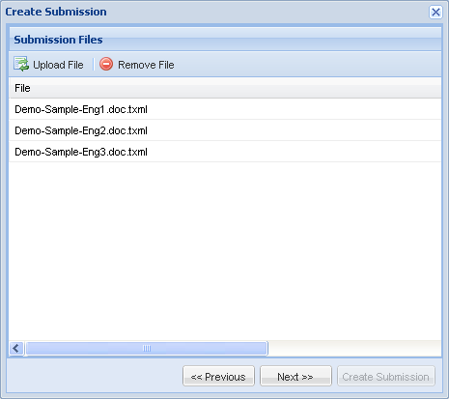
2. Complete the following entries:

| Option | Description |
| --- | --- |
| **Submission Files** | |
| Upload File | Click to browse and upload files.  Files can be uploaded in two ways:   * One-by-one: You can upload different file types, such as TXML or TTX * Batch or ZIP file: You can upload only one type of file, either TXML or TTX   TTX file format is only supported for review submissions.  You must ensure that the source and target language of the files match the language pair entered here. |
| Remove File | Select an uploaded file and click to remove the file. |

1. Click **Next**.  
   The Create Submission wizard - Glossaries dialog box appears.  
   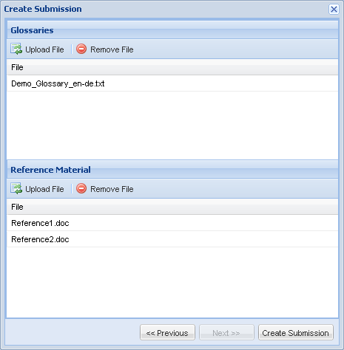
2. Complete the following entries:

| Option | Description |
| --- | --- |
| **Glossaries** | |
| Upload File | Click to browse and upload glossary file for the selected language.  The glossary file should be in tab-delimited format and UTF-8 or UTF-16 encoded without a unicode signature (BOM).  When you review a file, the glossary terms are highlighted in the source segments. The translation and description of the term appear as a tool tip on mouse over.  The maximum character count allowed for glossary source and target terms is 255 characters and for description or comments it is 600 characters. In addition, the glossary file can have a maximum of 3 columns. |
| Remove File | Select an uploaded glossary file and click to remove the file. |
| **Reference Material** | |
| Upload File | Click to browse and upload reference file(s) for the submission.  Files can be uploaded in two ways:   * One-by-one: You can upload different file types * Batch or ZIP file: You can upload different file types. While uploading a batch or ZIP file you must select the **Extract Compressed Files** checkbox. |
| Remove File | Select uploaded reference file(s) and click to remove file. You can select multiple files at once by pressing **Ctrl-click** or **Shift-click**. |

1. Click **Create Submission**.  
   The new submission is created. The submission details appear on the System Administrator dashboard and depending upon the workflows selected, an automated email notification is sent to the Translator or Supervisor and Reviewer.

|  |  |  |  |
| --- | --- | --- | --- |
| Important |  |  |  |
| The uploaded submission files, glossaries and reference files may take between 5-15 minutes to process. During this processing time, the submission appears in **Pending** status highlighted in yellow in the submission list. The Translator or Supervisor and Reviewer will not be able to access the submission until this process is complete. You must not modify a submission while it is in **Pending** status as it may lock the submission.  The automated email notification to the Translator or Supervisor and Reviewer is sent only after the submission creation process is complete and the submission highlight color changes from yellow to white. | | | |

## Creating a submission from template

The administrator can upload client-specific submission templates that can be used by project managers to quickly create submissions when majority of the entries are the same.

To create a submission from template:

1. On the System Administrator dashboard, click **Submissions > Create Submission From Template** as shown in the screenshot below.  
   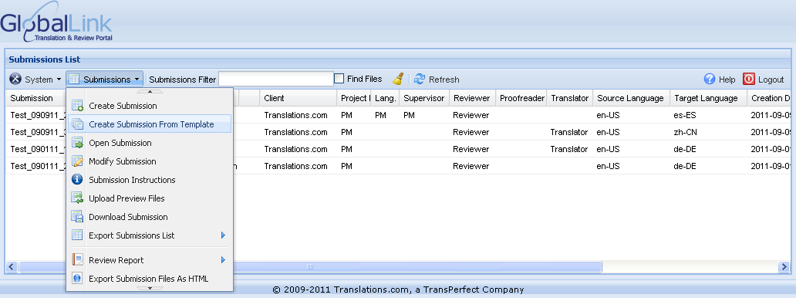  
   The Create Submission wizard - Submission Details dialog box appears.  
   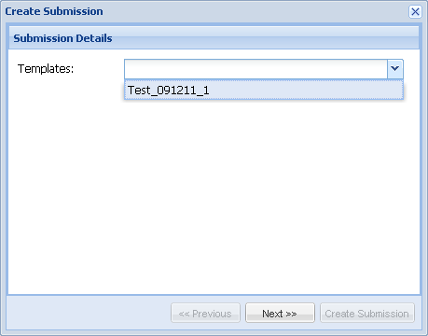
2. Select the submission template from the drop down list and click **Next**.  
   The Create Submission wizard - Submission Details dialog box appears. The basic Submission Details and Submission Workflow stages are automatically selected as shown in the screenshot below.  
   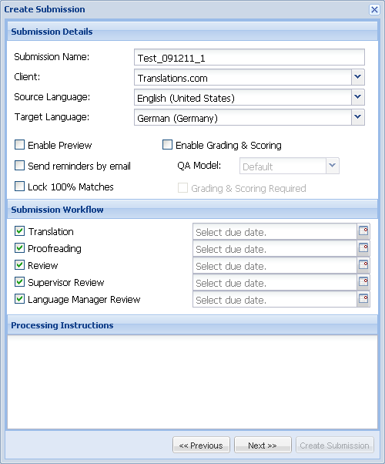
3. Complete any edits if required.

|  |  |  |  |
| --- | --- | --- | --- |
| Important |  |  |  |
| You will be required to select the due date for all the workflow steps. Refer to Creating a submission on page 43 for more information. | | | |

1. Click **Next**.  
   The Create Submission wizard - Submission Participants dialog box appears. The Submission Participants, TM Server and TermManager Server details are automatically populated from the template.  
   

|  |  |  |  |
| --- | --- | --- | --- |
| Important |  |  |  |
| The TM Server information that is pre populated from the template can be changed during submission creation. The information entered at the submission creation level will take precedence over that entered by the administrator in the Client TM Servers option.  There are five ways to access a glossary:   * 1. Term Manager glossaries: The TermManager Server information is entered in the TermManager Glossaries option by the administrator. Refer to Managing Term Manager glossaries on page 20 for more information.   2. Client Glossaries: The client glossaries are uploaded by the administrator. Refer to Uploading client glossaries on page 23 for more information.   3. Submission Templates: The TermManager Server information is entered in the submission template by the administrator. Refer to Managing submission templates on page 27 for more information.   4. Create Submission - TermManager Server option: The TermManager Server information is entered during submission creation by the project manager.   5. Create Submission - Glossaries option: The client glossary is uploaded during submission creation by the project manager. It is a best practice to either provide the TermManager Server information or upload a glossary to get best results of glossary matches. | | | |

1. Complete any edits if required and click **Next**.  
   The Create Submission wizard - Submission Files dialog box appears.  
   
2. Complete the following entries:

| Option | Description |
| --- | --- |
| **Submission Files** | |
| Upload File | Click to browse and upload files.  Files can be uploaded in two ways:   * One-by-one: You can upload different file types, such as TXML or TTX * Batch or ZIP file: You can upload only one type of file, either TXML or TTX   TTX file format is only supported for review submissions.  You must ensure that the source and target language of the files match the language pair entered here. |
| Remove File | Select an uploaded file and click to remove the file. |

1. Click **Next**.  
   The Create Submission wizard - Glossaries dialog box appears.  
   
2. Complete the following entries:

| Option | Description |
| --- | --- |
| **Glossaries** | |
| Upload File | Click to browse and upload glossary file for the selected language.  The glossary file should be in tab-delimited format and UTF-8 or UTF-16 encoded without a unicode signature (BOM).  When you review a file, the glossary terms are highlighted in the source segments. The translation and description of the term appear as a tool tip on mouse over.  The maximum character count allowed for glossary source and target terms is 255 characters and for description or comments it is 600 characters. In addition, the glossary file can have a maximum of 3 columns. |
| Remove File | Select an uploaded glossary file and click to remove the file. |
| **Reference Material** | |
| Upload File | Click to browse and upload reference file(s) for the submission.  Files can be uploaded in two ways:   * One-by-one: You can upload different file types * Batch or ZIP file: You can upload different file types. While uploading a batch or ZIP file you must select the **Extract Compressed Files** checkbox. |
| Remove File | Select uploaded reference file(s) and click to remove file. You can select multiple files at once by pressing **Ctrl-click** or **Shift-click**. |

1. Click **Create Submission**.  
   The new submission is created. The submission details appear in the System Administrator dashboard and depending upon the workflows selected, an automated email notification is sent to the Translator or Supervisor and Reviewer.

|  |  |  |  |
| --- | --- | --- | --- |
| Important |  |  |  |
| The uploaded submission files, glossaries and reference files may take between 5-15 minutes to process. During this processing time, the submission appears in **Pending** status highlighted in yellow in the submission list. The Translator or Supervisor and Reviewer will not be able to access the submission until this process is complete. You must not modify a submission while it is in **Pending** status as it may lock the submission.  The automated email notification to the Translator or Supervisor and Reviewer is sent only after the submission creation process is complete and the submission highlight color changes from yellow to white. | | | |

## Modifying a submission

A submission can be modified at any time once started. You must not modify a submission while it is in **Pending** status as it may lock the submission.

To modify a submission:

1. On the System Administrator dashboard, click on a submission from the submission list.
2. Click **Submissions > Modify Submission** as shown in the screenshot below.  
   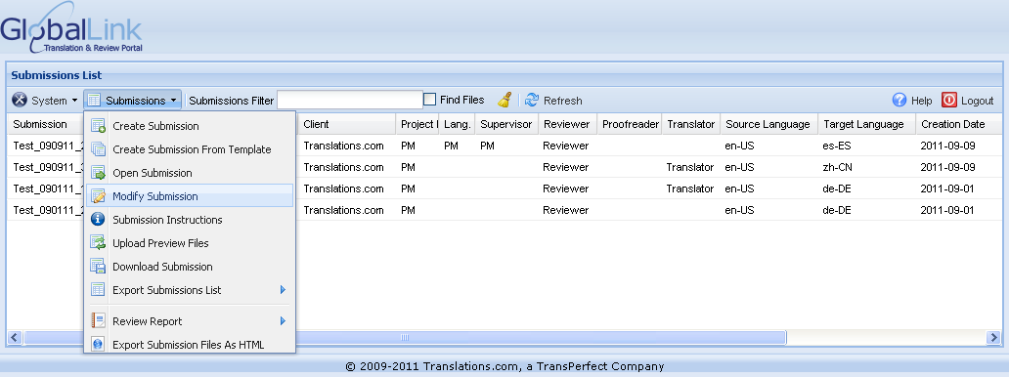   
   The Modify Submission wizard appears.   
   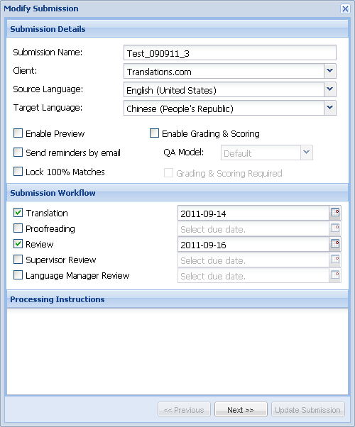
3. Complete the necessary changes in the Submission Details, Submission Workflow and Processing Instructions.
4. Click **Next** and complete changes in Submission Participants, TM Server, Submission Files, Glossary and Reference material sections.

|  |  |  |  |
| --- | --- | --- | --- |
| Important |  |  |  |
| To remove submission files, you can select multiple files at once by pressing **Ctrl-click** or **Shift-click**. In the Glossaries section, uncheck the **Replace Files** checkbox if you want to retain the existing glossary. | | | |

1. Click **Update Submission**.  
   The submission is modified and the submission details appear in the System Administrator dashboard.

## Deleting a submission

To delete a submission:

1. On the System Administrator dashboard, click on a submission from the submission list.
2. Click **Submissions > Delete Submission** as shown in the screenshot below.  
   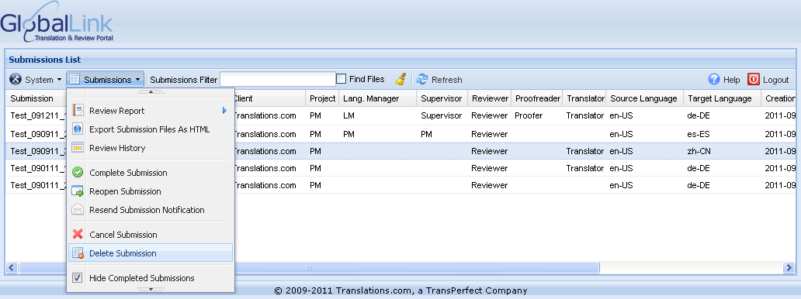   
   A warning message appears.  
   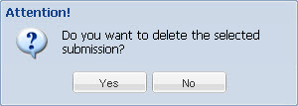
3. Click on Yes to delete a Submission or Click on No to undo the action.

After deleting, the submission disappears from the Submissions list.

## Downloading a submission

To download a submission:

1. On the System Administrator dashboard, click on a submission from the submission list.
2. Click **Submissions > Download Submission** as shown in the screenshot below.  
   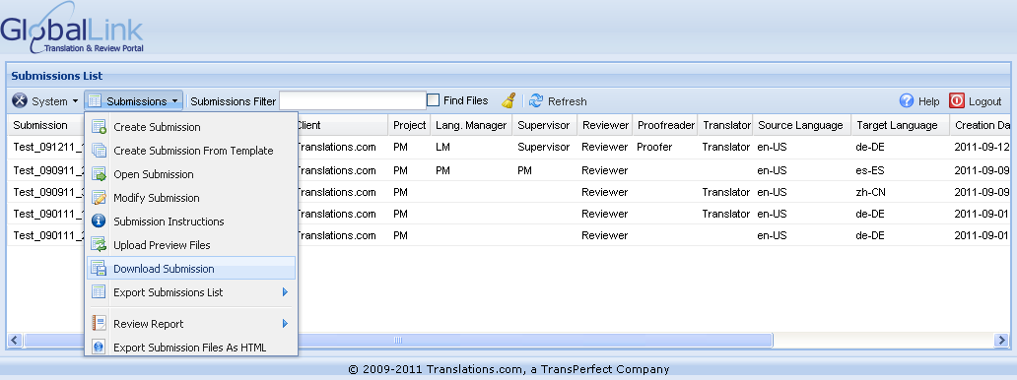  
   The tool prepares the submission files for download and the Download dialog box appears.
3. Click **Download**.
4. Save the submission to a preferred location.

## Generating a review report

To generate a review report:

1. On the System Administrator dashboard, click on a submission from the submission list.
2. Click **Submissions > Review Report** as shown in the screenshot below.   
   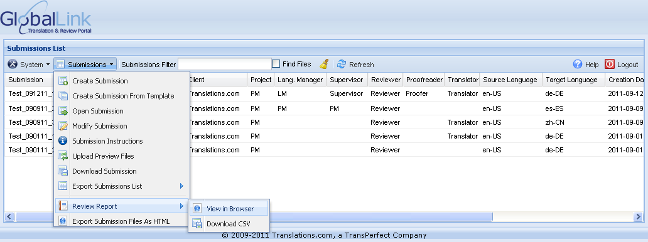  
   You have two options:

* To view the review report in the browser, click **View in Browser**.  
  The tool processes the submission and prompts you to **Open Report**. Find below a screenshot of a review report in the browser view:  
  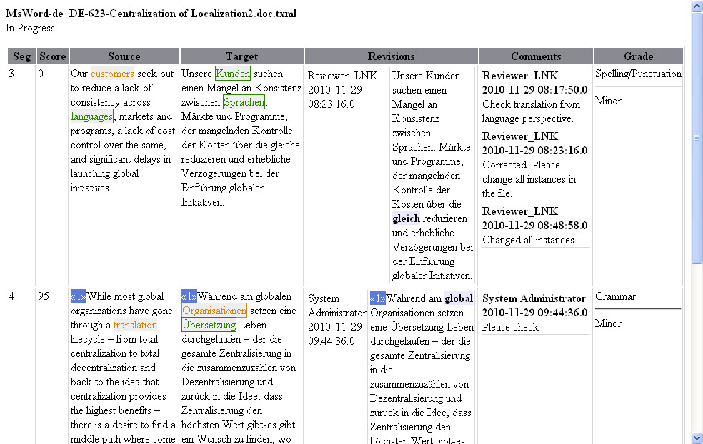
* To download the review report as a comma-separated (CSV) file, click **Download CSV**.  
  The tool processes the submission and prompts you to **Download** and save a copy of the submission statistics to your computer. Find below a screenshot of a review report in the CSV format:  
  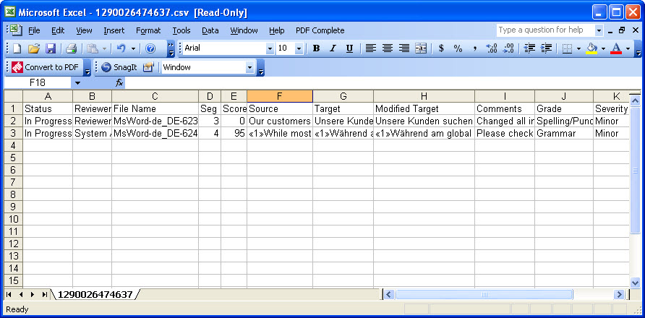

|  |  |  |  |
| --- | --- | --- | --- |
| Important |  |  |  |
| The review report includes all submission statistics, such as list of files, review status, reviewer details, source, target and modified target segments and notes. | | | |

## Viewing or hiding completed submissions

The GlobalLink Translation & Review Portal allows the System Administrator to unhide or hide completed submissions. This helps you keep track of the submissions that are being worked on.

To unhide or hide completed submissions in the submissions list:

1. On the System Administrator dashboard, click **Submissions**.  
   The Submissions menu options appear.   
   
2. Click **Hide Completed Submissions** checkbox.   
   The tool processes the submissions details and unhides or hides the completed submissions.

//The screenshot does not show the mentioned feature i.e **Hide Completed Submissions** checkbox.

## Viewing review history

To view the review history:

1. On the System Administrator dashboard, click on **Submissions > Review History**.  
   The Review History dialog box appears.  
   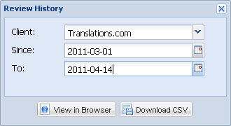
2. Complete the following entries:

| Option | Description |
| --- | --- |
| Client | Select the client from the drop down list. |
| Since | Select or type the date from when the review history should be populated. The date format is yyyy-mm-dd. |
| To | Select or type the date until when the review should be populated. The date format is yyyy-mm-dd. |

1. You have two options:

* To view the review history in the browser, click View in Browser.  
  The tool processes the review history and prompts you to Open File. Find below a screenshot of the review history in the browser view.  
  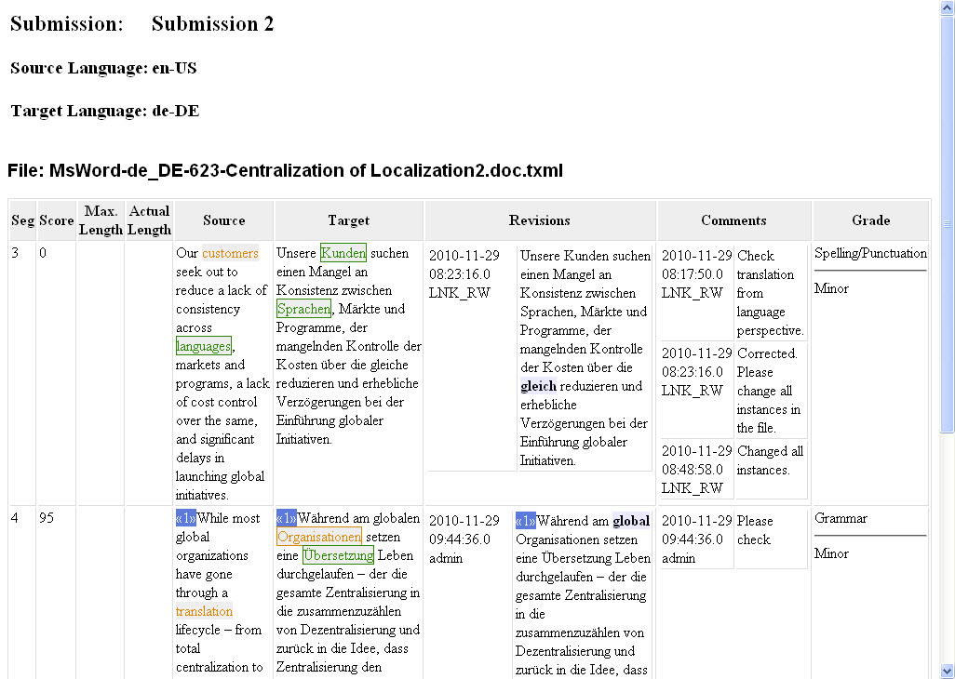
* To download the review history as a comma-separated (CSV) file, click Download CSV.  
  The tool processes the review history and prompts you to Download and save a copy of the review history to your computer. Find below a screenshot of the review history in CSV format.  
  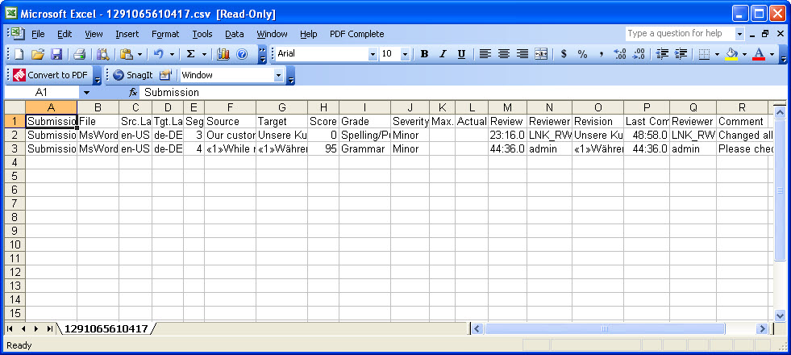

|  |  |  |  |
| --- | --- | --- | --- |
| Important |  |  |  |
| The review history includes all submission statistics for the selected date range. The statistics includes submission names, source and target locales, file list, review status, reviewer details, source, target and modified target segments and comments. | | | |

## Reopening a submission

To reopen a submission:

1. On the System Administrator dashboard, click on a submission from the submission list.
2. Click **Submissions > Reopen Submission** as shown in the screenshot below.  
   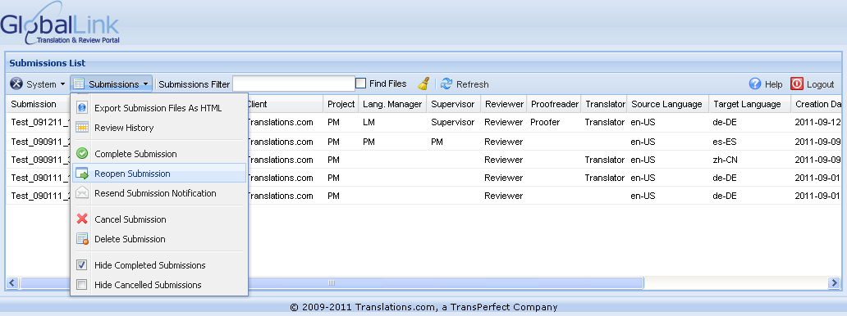  
   The Reopen Submission dialog box appears.  
   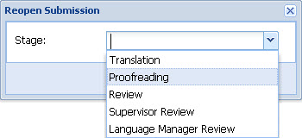
3. Select the workflow stage from where the submission should restart.

|  |  |  |  |
| --- | --- | --- | --- |
| Important |  |  |  |
| The stage options will correspond to the workflow options selected during submission creation. | | | |

1. Click **Accept**.  
   An automated email notification is sent to the user assigned to the selected workflow stage.

## Filtering submissions

You can filter submissions based on submission name and find files within a submission.

### Filtering by submission name

To filter submissions based on submission name:

1. On the System Administrator dashboard, enter the submission name or part of the submission name in the Submissions Filter text box.
2. Press **Enter** on your keyboard.  
   The submissions with the entered text filter appear as shown in the screenshot below.  
   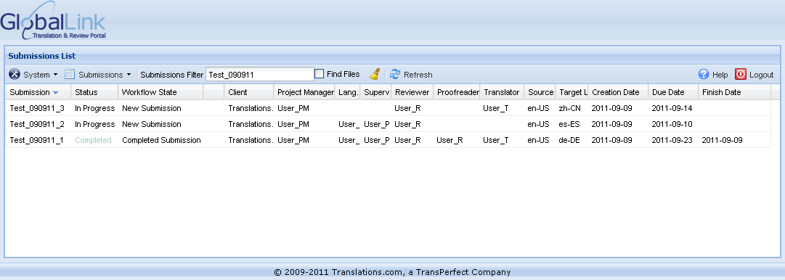
3. Click on  to clear the entered text filter and view all submissions.

### Finding files in a submission

To find files within a submission:

1. On the System Administrator dashboard, check the **Find Files** checkbox.
2. Enter the file name or part of the file name in the Submissions Filter text box as shown in the screenshot below.  
   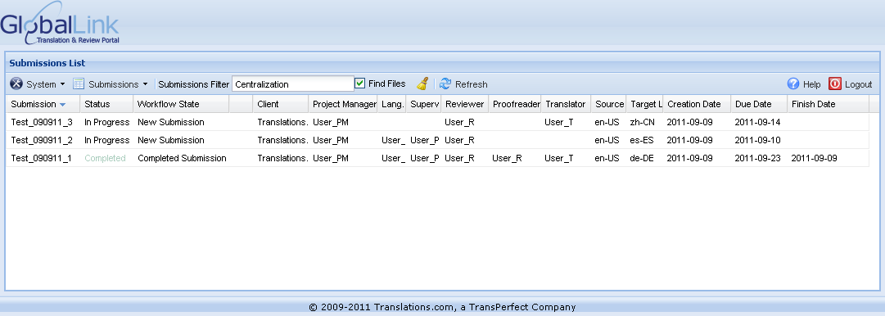
3. Press **Enter** on your keyboard.  
   The submissions that include files with the entered text filter appear.  
   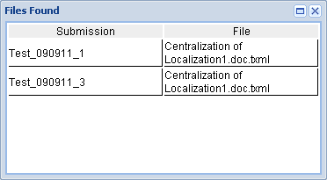
4. Click on  to clear the entered text filter and view all submissions.